**CHAPTER ONE**

1. **INTRODUCTION**
   1. **BACKGROUND OF THE STUDY**

The purpose of this project is to develop a program that will uses Arduino Uno, Ethernet shield and temperature sensor in order to monitor human body temperature through a web browser and store the information into database management system software. Arduino is a small microcontroller board with a universal serial bus (USB) plug to connect to your computer and a number of connection sockets that can be wired to external electronics such as motors, relays, light sensors, laser diodes, loudspeakers, microphones and more. They can either be powered through the USB connection from the computer, from a 9V battery, or from a power supply. They can be controlled from the computer or programmed by the computer and then disconnected and allowed to work independently. The board design is open source. This means that anyone is allowed to make Arduino compatible boards. This competition has lead to low costs for the boards. The basic boards are supplemented by accessory shield boards that can be plugged on top of the Arduino board. we will use two shields—an LCD display shield and an Ethernet shield—that will allow us to turn our Arduino into a tiny web server. The software for programming your Arduino is easy to use and also freely available for Windows computers.

Arduino 2011a. Introduction. Available. Accessed: 13 April 2016. Arduino isa microcontroller platform that has captured the imagination of electronics enthusiasts. Its ease of use and open source nature make it a great choice for anyone wanting to build electronic projects. Ultimately, it allows you to connect electronics through its pins so that it can control things for instance, turn lights or motors on and off or sense things such as light and temperature. This is why Arduino is sometimes given the description physical computing. Because Arduinos can be connected to your computer by a universal serial bus (USB) lead, this also means that you can use the Arduino as an interface board to control those same electronics from your computer.

The heart of your Arduino is a microcontroller. Pretty much everything else on the board is concerned with providing the board with power and allowing it to communicate with your desktop computer. A microcontroller really is a little computer on a chip. It has everything and more than the first home computers had. It has a processor, a kilobyte or two of random access memory (RAM) for holding data, a few kilobytes of erasable programmable read-only memory (EPROM) or flash memory for holding your programs and it has input and output pins. These input/output (I/O) pins link the microcontroller to the rest of your electronics.

**1.2 STATEMENT OF THE PROBLEM**

Some of problem that lead to these research project are poor documentation and improper temperature monitoring system which has cause some of the hospital to lost vital information about patient. Lack of information and communication technology like some of hardware devices , internet and web applications to monitor the health of their clients has limit some of the hospital services into restricted environment.

**1.3 SIGNIFICANCE OF THE PROJECT**

The important of this project research is to develop web based application to store the information of their patient into a database using php, MySQL and Ethernet shield.

**1.4 AIMS**

The aim of this project is to develop web application software that can monitor the temperature of their patient in hospital with the help of devices such like, Ethernet shield, Arduino UNO, and web programming application.

**1.5 OBJECTIVE**

(1) The arduino uno and the temperature sensor, the IDE Arduino application software is used to transfer the temperature reading into the computer system.

(2) Ethernets shield devices capture the data and send it to the web browser with the help of IP and router.

(3) HTML, PHP, MYSQL are the web programing language to generate the code and stored the information into the database management system.

**1.6 METHODOLOGY**

**1.6.1 CIRCUIT DIAGRAM OF ARDINO UNO**

+v

Ardino

uno



//

-V

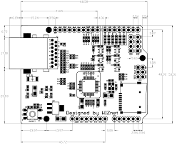

**Ethernet shield**

In this architecture first stage is temperature sensor, which give analog values according to current temperature. We generally measured in Celsius form. This analog value is given to Arduino Uno channel for conversion. After conversion from A/D, the result will be stored into the memory. Temperature reading is converted into Fahrenheit and serially transmitted over serial port . Graph life temperature readings will displayed. To display current temperature reading in the web page. The web based protocol HTTP is used and web site is designed into simple HTML language.

Basically, we used Ethernet shield for joining the web—server concept to this project. HTML based website is developed in Arduino programming and transmitted over a LAN of internet via Ethernet shield to the PC/clients.

**1.6.2 BLOCK DIAGRAM OF ARDINO UNO CONNECT WITH**

**TEMPERATURE**

**Temperature sensor**

Arduino UNO

Bread Board

Ethernet

Computer

Web browser

Web Page

**1.7 SCOPE OF THE STUDY**

This project is to develop a database like SQL and PHP with Ethernet shield to store the information of the patient and display the with web browser.

**1.8** **DEFINITION OF TERMS**

**The Arduino Uno board:-** is a microcontroller based on the ATmega328. It has 14 digital **input/output pins** in which 6 can be used as **PWM outputs**, a 16 MHz ceramic resonator, an ICSP header, a USB connection, 6 analog inputs, a power jack and a **reset** button.

**Sensor :-** A sensor is a device that detects and responds to some type of input from the **physical** environment.

Temperature Sensor :- Contact sensors include thermocouples and thermistors that touch the object they are to **measure**, and **noncontact** sensors **measure** the thermal radiation a heat source releases to determine its temperature.

**Local Area Network (LAN):-**  Is a group of computers and associated devices that share a common communications line or wireless link to a server.

**Bread Board :**- An electronics breadboard (as opposed to the type on which sandwiches are made) is actually referring to a solder less breadboard. These are great units for **making temporary** circuits and prototyping, and they require absolutely no soldering.

Hypertext Markup Language,(HTML):- is the authoring language used to create documents on the World Wide Web.

**PHP:-** is a general-purpose scripting language that is especially suited to server-side web development, in which case PHP generally runs on a web server.

**MySQL** is a freely available open source Relational **Database** Management System (RDBMS) that uses Structured Query Language (SQL). SQL is the most popular language for adding, accessing and managing content in a **database**.

**USB port :- is** a standard **cable connection interface** for personal computers and consumer electronics devices.

**RAM** :- is considered volatile memory, which **means** that the stored information is lost when there is no power. So, RAM is used by the central processing unit (CPU) when a computer is **running** to **store** information that it needs to be used very quickly.

**EPROM (erasable programmable read-only memory)**:- is programmable read-only memory (programmable ROM) that can be erased and re-used. Erasure is caused by shining an intense ultraviolet light through a window that is designed into the memory chip.

**CHAPTER TWO**

1. **LITERATURE REVIEW**

**2.1 INTRODUCTION**

Temperature is a numerical representation of hot or cold compared against baselines, typically the point at which water freezes and boils. In most in instances, temperature measures how much heat there is in a particular entity in a liquid, such as water, or a solid, such as soil. In meteorology, temperature measures the heat content of the atmosphere. The instrument used to measure temperature is a thermometer, a word derived from the Greek thermos, meaning "hot," and metron, "measure. Dr. Karima Elshamy Faculty of Nursing Mansoura University Egypt in (2015) define a temperature as It is the degree of heat maintained by the body or it is the balance between heat produced in the tissues and heat lost to the environment. Despite extremes in environmental conditions and physical activity, temperature-control mechanisms of human beings keep the body core temperature (temperature of the keep tissues) relatively constant. However, surface temperature fluctuates depending on blood flow to the skin and amount of heat lost to the external environment.

Galen, a Greek scientist and physician in (2013) define temperature as the average temperature of the human body. In humans, this average temperature is estimated at around 37°C, although this can vary depending on time of day, typically by 0.5°C in the evening compared to the morning. The center that regulates the body temperature is located in a gland, the pituitary gland, and the exact point of regulation can be changed in the event of damage or disease, hence the outbreak of fever when the body is attacked by infection.

According to purists, from hyperthermia, in 2016 which defines an increase in body temperature caused by the environment or physical exertion, and [hypothermia](https://health.ccm.net/faq/374-hypothermia), which is a decrease and is essentially due to prolonged exposure to the cold. In both of these cases, the point of regulation is not changed, and the body initiates certain processes designed to bring the temperature back to normal, such as by sweating or shivering.

**2.2 HISTORY OF THE THERMOMETER**

Galen, a Greek scientist and physician, made the first attempt at measuring temperature in A.D. 170. He documented a standard "neutral" temperature of equal parts of boiling water and ice. He added four degrees of heat and four degrees of cold on either side of this neutral temperature.

The concept of measuring temperature is fairly new. The thermoscope essentially a thermometer without a scale was the precursor to the modern thermometer. There were several inventors working on thermoscopes around 1593, but the most well known is [Galileo Galilei](https://www.space.com/15589-galileo-galilei.html), an Italian inventor who also improved upon (but did not invent) the [telescope](https://www.space.com/21950-who-invented-the-telescope.html).

A thermoscope could show the differences in temperature, allowing observers to know if something was getting hotter or colder. However, the thermoscope could not provide an exact temperature in degrees. In 1612, the Italian inventor Santorio. Santorio added a numerical scale on his thermoscope and it was used to take human temperature.

Ferdinand II, the Grand Duke of Tuscany, followed in 1654, inventing the first enclosed thermometer, using alcohol as a liquid. But it still lacked a standardized scale and was not very accurate. Around the same time, German physicist Daniel Gabriel Fahrenheit met Olaus Roemer, a Danish astronomer, who developed an alcohol-based thermometer using wine. He marked two points on his thermometer — 60 to mark the temperature of boiling water and 7.5 as the point where ice melted.

In 1714, Fahrenheit refined Roemer’s invention and developed the first modern thermometer — the mercury thermometer with more refined measurements. The mercury expands or contracts as the temperature rises or falls.Fahrenheit had invented an alcohol thermometer in 1709 prior to unveiling its mercury counterpart, which proved to be more accurate.

Ten years later, he unveiled his namesake Fahrenheit scale, which divided the freezing and boiling points of water into 180 degrees. It established 32 degrees was the freezing pint of water and 212 degrees was the boiling point of water. An equal mixture of water, ice and ammonium chloride, a salt, was used to set the temperature of 0.

**2.3 THE RISE OF THE TEMPERATURE SCALES**

Fahrenheit is one of three major temperature scales used today, with the other two being Celsius and Kelvin. Fahrenheit is the standard used for measuring temperature in the United States, but most of the rest of the world uses Celsius. Not too long after the Fahrenheit scale was unveiled, Swedish astronomer Anders Celsius came out with his temperature scale, which is referred to as the Celsius scale. It is sometimes called the centigrade scale, because it is divided into 100 degrees separating the boiling and freezing points of water.  The original scale set 0 as the boiling point of water and 100 as the freezing point, but he flipped it around soon after inventing the scale.

The term Celsius was adopted in 1948 by an international conference on weights and measures and the scale is the preferred temperature gauge for scientific applications as well as most of the world outside of the United States.

Lord Kelvin of Scotland chimed in with his temperature gauge in 1848, known as the Kelvin scale. He based it on the idea of absolute temperature, a theoretical temperature at which all substances have no heat energy.  There are no negative numbers on the Kelvin scale, 0 K being the coldest temperature possible.

Absolute zero converts to minus 273.15 C and minus 459.67 F. The Kelvin scale is commonly used in scientific applications. The units on the Kelvin scale are the same size as those of the Celsius scale, except that the Kelvin scale sets the lowest temperature at 0.

**2.4 SITES AND NORMAL RANGES OF MEASURING BODY TEMPERATURE**

* The average of normal oral temperature is 37C.
* The acceptable temperature of human being ranges from 36 c – 38 C.
* The normal range of oral temperature is 36.1C – 37.5 C.
* The normal range of rectal temperature is 36.1C– 38.1 C.
* The normal range of axillary temperature is 35.5–36.4 C.
* The normal range of tympanic temperature is 36.4 C – 38.1C.
* Temperature of 34°C to 41 °C is the approximate range within which body cells can function.
* If body temperature decreased than 34°C or increased than 41°C body, cells can not function.
* Temperature can be measured with a mercury thermometer, an electronic digital thermometer, or a tympanic thermometer.
* Body temperature is recorded either in degree centigrade (C) or degree Fahrenheit (F).
* To convert centigrade to Fahrenheit, multiply by 9/5 and add 32.
* F= (9/5 x C) + 32
* To Change Fahrenheit to Centigrade subtract 32 and multiply by 5/9.
* C= (F-32) x 5/9

**2.5 TEMPERATURE REGULATION**

There are various regulating factors that affect body temperature. These are:

• Physical control.

• Chemical control.

• Nervous system control.

**2.5.1 PHYSICAL CONTROL**

The body gains heat from its environment, for example clothing, sun and ingestion of hot food.

**2.5.2 CHEMICAL CONTROL**

The body produces heat through the metabolism of food and Body metabolism increases in order to produce more heat for the body as necessary. Thus, the rate at which metabolism takes place affects and controls body temperature, an increase in the metabolic rate will result in an increase in body temperature and vice versa.

**2.5.3 NERVOUS SYSTEM CONTROL.**

Body temperature is maintained by the hypothalamus in the central nervous system, located at the base of the brain. The anterior portion of the hypothalamus is concerned with heat dissipation (loss), and the posterior portion of the hypothalamus governs heat conservation (gain).

**2.6** **HEAT DISSIPATING MECHANISM**

The anterior part of the hypothalamus is stimulated by very slight increase in the temperature of the blood above normal. And It stimulates the sweat glands to increase their rate of secretion. Also Evaporation of the larger amount of sweat causes a greater heat loss which causes dilatation of surface blood vessels; so more heat is lost by radiation from the larger quantity of blood circulating near the surface in the dilated skin vessels.

**2.7** **HEAT GAINING MECHANISM**

In a cold environment, the posterior portion of the hypothalamus is stimulated, this causes skin blood vessels constriction which decreases the volume of blood circulating near the surface and so decreases the heat loss by radiation. In addition there is decrease in activity of sweat gland. Thus, decreases heat loss by evaporation. Also shivering and voluntary muscle contractions occur, thereby accelerating catabolism and heat production.

**2.8 MECHANISMS OF HEAT LOSS**

Body heat is lost through the skin, lungs, and excretion (digestive and urinary tracts). The loss through the skin accounts about 85% of the total.

**2.9** **THERE ARE FOUR MECHANISMS BY WHICH HEAT LOSS TAKES PLACE**

1. Radiation: is the process whereby heat is transferred from one object to another without direct contact between the two. The heat is carried from one object to the other in the form of rays. For example, the use of heat lamp involves the transfer of heat by radiation.

2. Convection: heat is lost through convection when air currents pass over a warm object, carrying its heat away with them. • For example, using of fans, open doors and windows to Create drafts.

3. Conduction: is the transfer of heat by direct contact between two objects. Heat passes from the warmer object to the colder. For example, contact between skin of increased temperature and cold water, swimming or cold showers.

4. Evaporation: process whereby a substance in liquid state is changed to a vapor state. The more heat the body generates (as in muscular exertion), the more active the sweat glands become, thereby, increasing the rate of cooling. For example, sponging a patient with alcohol and water provide for cooling by evaporation, Also evaporation of water vapor through respiratory tract with expiration.

**2.10 FACTORS INCREASING HEAT PRODUCTION**

1. **Muscular activity:** leads to an increase in tissue metabolism which in turn increases heat production, e.g. shivering, muscular exercises.

2. **Ingestion of food**: by increasing the fuel supply, body heat is increase.

3. **Time of day:** Body temperature tends to be at its highest in the late afternoon or early evening.

4. **Emotion:** stimulate the sympathetic nervous system with release of epinephrine and nor epinephrine, which increases the metabolic activities of body tissues which in turn increases heat production.

5. **Hormones:** increase in the production of thyroxin by the thyroid gland increases basal metabolic rate thereby stimulates heat production.

6. Infections: cause increase in body temperature.

7. **Increased temperature of the environment**: high room temperature or a hot water bath may increase body temperature.

8. **Menstruation and pregnancy:** At a time of ovulation a woman's body temperature may raise as much as 0.3oC. It falls again one or two days before the onset of menstruation. The first 3 to 4 months of pregnancy are characterized by a slight rise of the temperature, then falls slightly below normal for the remainder of the pregnancy. It returns to normal after child birth.

**2.11 FACTORS DECREASING HEAT PRODUCTION**

**1. Prolonged illness:** muscular activity is diminished and less heat is produced.

**2. Fasting:** an inadequate supply of food or fuel leads to decreased heat production.

**3. Sleep:** during sleep, when the body is less active, less heat is produced and body temperature is lowered.

**4. Depression of the nervous system:** mental depression, unconsciousness and the use of narcotic drugs, all act to lessen body activity and thus, decrease heat production.

**5. Time of day**: body temperature tends to be at its lowest in the morning 6. Age: the body temperature of young children tends to vary more than that of adults. This is due to the relative immaturity of the child's nervous system. In the aged the temperature is subnormal because the body is less active, the circulation is feeble, and therefore, old people are intolerable extremes of external temperature.

**2.12 MEASURES TO REDUCE BODY TEMPERATURE**

i. Bed rest and inactivity to decrease the rate of the metabolic process and also muscular activity, thereby, decrease the amount of heat produced in the body.

ii. Sponging the patient's body a cool solution of water and alcohol to promote heat loss by evaporation.

iii. Ice bags on the grin, axilla and forehead to promote heat loss by conduction.

iv. Cool quiet environment to promote heat loss by radiation and convection.

v. Force cold fluids up to 2.500 to 3000 cc/day, in small amount and frequent intervals. Fluids increase sweating, which promotes heat loss through evaporation.

vi. Administration of antipyretic drug according to doctor's order.

**2.13 HYPOTHERMIA**

A condition in which temperature is abnormally lower than normal Classification of hypothermia:

• Mild: 34o – 36o C

• Moderate: 30o – 34o C

• Sever: 30o – 0oC

**2.13.1 CAUSES OF HYPOTHERMIA**

1. Lowered metabolism.

2. Decreased activity usually occurs in elderly.

3. Heavy sedation.

4. Circulatory failure.

5. Exposure to extremely cold environmental temperature.

**2.13.2 SIGNS AND SYMPTOMS OF HYPOTHERMIA**

1. Pale skin.
2. Cyanosed lips.
3. Cold hands and feet.
4. Chilling.
5. Goose skin.
6. Drowsiness.
7. Slow pulse rate.
8. Slow respiration.
9. Decreased physical and mental capabilities.
10. Patient feels sleepy and may become comatose.
    1. **APPLICATIONS OF MICROCONTROLLER**
11. Consumer Electronics Products: Toys, Cameras, Robots, Washing Machine, Microwave Ovens etc. [ ...
12. Instrumentation and Process Control: Oscilloscopes, Multi-meter, Leakage Current Tester, Data Acquisition and Control etc.
13. Medical Instruments
14. Communication
15. Office Equipment
16. Multimedia Application
17. Automobile:
    * 1. **CLASSIFICATION OF MICROCONTROLLER**

The microcontrollers are characterized regarding bus-width, instruction set, and memory structure.

### CLASSIFICATION ACCORDING TO NUMBER OF BITS

In **8-bit** microcontroller, the point when the internal bus is 8-bit then the ALU is performs the arithmetic and logic operations. The examples of 8-bit microcontrollers are Intel 8031/8051, PIC1x and Motorola MC68HC11 families.

The **16-bit** microcontroller performs greater precision and performance as compared to 8-bit. For example 8 bit microcontrollers can only use 8 bits, resulting in a final range of 0×00 – 0xFF (0-255) for every cycle. In contrast, 16 bit microcontrollers with its 16 bit data width has a range of 0×0000 – 0xFFFF (0-65535) for every cycle. A longer timer most extreme worth can likely prove to be useful in certain applications and circuits. It can automatically operate on two 16 bit numbers. Some examples of 16-bit microcontroller are 16-bit MCUs are extended 8051XA, PIC2x, Intel 8096 and Motorola MC68HC12 families.

The **32-bit** microcontroller uses the 32-bit instructions to perform the arithmetic and logic operations. These are used in automatically controlled devices including implantable medical devices, engine control systems, office machines, appliances and other types of embedded systems. Some examples are Intel/Atmel 251 family, PIC3x.

### CLASSIFICATION ACCORDING TO MEMORY DEVICES

**Embedded memory microcontroller**: When an embedded system has a microcontroller unit that has all the functional blocks available on a chip is called an embedded microcontroller. For example, 8051 having program & data memory, I/O ports, serial communication, counters and timers and interrupts on the chip is an embedded microcontroller.

**External Memory Microcontroller**: When an embedded system has a microcontroller unit that has not all the functional blocks available on a chip is called an external memory microcontroller. For example, 8031 has no program memory on the chip is an external memory microcontroller.

### 2.14.1.3 CLASSIFICATION ACCORDING TO MEMORY ARCHITECTURE

**Harvard Memory Architecture Microcontroller**: The point when a microcontroller unit has a dissimilar memory address space for the program and data memory, the microcontroller has Harvard memory architecture in the processor.

**Princeton Memory Architecture Microcontroller**: The point when a microcontroller has a common memory address for the program memory and data memory, the microcontroller has Princeton memory architecture in the processor.

### CLASSIFICATION ACCORDING TO INSTRUCTION SET

1. **CISC**: CISC is a Complex Instruction Set Computer. It allows the programmer to

use one instruction in place of many simpler instructions.

1. **RISC**: The RISC is stands for Reduced Instruction set Computer, this type of instruction sets reduces the design of microprocessor for industry standards. It allows each instruction to operate on any register or use any addressing mode and simultaneous access of program and data.

**Example for CISC and RISC**

|  |  |  |  |  |
| --- | --- | --- | --- | --- |
| **CISC**: | Mov AX, 4 | **RISC**: |  | Mov AX, 0 |
|  | Mov BX, 2 |  |  | Mov BX, 4 |
|  | ADD BX, AX |  |  | Mov CX, 2 |
|  |  |  | Begin | ADD AX, BX |
|  |  |  | Loop | Begin |

From above example, RISC systems shorten execution time by reducing the clock cycles per instruction and CISC systems shorten execution time by reducing the number of instructions per program. The RISC gives a better execution than the CISC.

### 2.14.1.5 TYPES OF MICROCONTROLLERS

**Microcontroller 8051**:- It is a 40pin microcontroller with Vcc of 5V connected to pin 40 and Vss at pin 20 which is kept 0V. And there are input and output ports from P1.0 – P1.7 and which having open drain feature. Port3 has got extra features. Pin36 has open drain condition and pin17 has internally pulled up transistor inside the microcontroller. When we apply logic 1 at port1 then we get logic 1 at port21 and vice versa. The programming of microcontroller is dead complicate. Basically we write a program in C-language which is next converted to machine language understand by the microcontroller. A RESET pin is connected to pin9, connected with a capacitor. When the switch is ON, the capacitor starts charging and RST is high. Applying a high to the reset pin resets the microcontroller. If we apply logic zero to this pin, the program starts execution from the beginning.

**Memory Architecture of 8051** :- The memory of 8051 is divided to two parts. They are Program Memory and Data Memory. Program Memory stores the program being executed whereas Data Memory temporarily stores the data and the results. The 8051 has been in use in a wide number of devices, mainly because it is easy to integrate into a device. Microcontrollers are mainly used in energy management, touch screen, automobiles, and medical devices.

**2.14.2 DIFFERENT TYPES OF ARDUINO BOARDS**

#### 2.14.2.1 ARDUINO UNO (R3)

Arduino. 2011b, Arduino Uno Available: http://arduino.cc/en/Main/arduinoBoardUno. Accessed: 14 March 2016.The Uno is a huge option for your initial Arduino. It consists of 14-digital I/O pins, where 6-pins can be used as PWM ([pulse width modulation](https://www.elprocus.com/pulse-width-modulation-pwm/) outputs), 6-analog inputs, a reset button, a power jack, a USB connection and more. It includes everything required to hold up the microcontroller; simply attach it to a PC with the help of a USB cable and give the supply to get started with a AC-to-DC adapter or battery.

#### 2.14.2.2. LILYPAD ARDUINO BOARD

Arduino.2011c.ArduinoDue.Available:http://www.arduino.cc/en/Main/Arduino BoardDue. Ac-cessed: 19 March 2016. The Lily Pad Arduino board is a wearable e-textile technology expanded by Leah “ Buechley”and considerately designed by “Leah and SparkFun”. Each board was imaginatively designed with huge connecting pads & a smooth back to let them to be sewn into clothing using conductive thread. This Arduino also comprises of I/O, power, and also sensor boards which are built especially for e-textiles. These are even washable.

#### 2.14.2.3 REDBOARD ARDUINO BOARD

The RedBoard aAduino board can be programmed using a Mini-B USB cable using the Arduino IDE. It will work on Windows 8 without having to modify your security settings.It is more constant due to the USB or FTDI chip we used and also it is entirely flat on the back. Creating it is very simple to utilize in the project design. Just plug the board, select the menu option to choose an Arduino UNO and you are ready to upload the program. You can control the RedBoard over USB cable using the barrel jack.

#### 2.14.2.4 ARDUINO MEGA (R3) BOARD

Arduino. 2011d. Arduino Shields. Available: http://arduino.cc/en/Main/ArduinoShields. Accessed: 15 April 2016. The Arduino Mega is similar to the UNO’s big brother. It includes lots of digital I/O pins (from that, 14-pins can be used as PWM o/ps), 6-analog inputs, a reset button, a power jack, a USB connection and a reset button. It includes everything required to hold up the microcontroller; simply attach it to a PC with the help of a USB cable and give the supply to get started with a AC-to-DC adapter or battery. The huge number of pins make this Arduino board very helpful for designing the projects that need a bunch of digital i/ps or o/ps like lots button.

## 2.14.2.5 ARDUINO ETHERNET SHIELD

## The [Arduino Ethernet Shield 2](https://www.arduino.cc/en/Main/ArduinoEthernetShield) allows an Arduino board to connect to the internet using the [Ethernet library](https://www.arduino.cc/en/Reference/Ethernet) and to read and write an SD card using the [SD library](https://www.arduino.cc/en/Reference/SD). This shield is fully compatible with the former version, but relies on the newer W5500 chip.

To use the shield, mount it on top of an Arduino board (e.g. the Uno). To upload sketches to the board, connect it to your computer with a USB cable as you normally would. Once the sketch has been uploaded, you can disconnect the board from your computer and power it with an external power supply. Connect the shield to your computer or a network hub or router using a standard ethernet cable (CAT5  with RJ45  connectors). Connecting to a computer may require the use of a cross-over cable (although many computers, including [all recent Macs](http://support.apple.com/kb/HT2274) can do the cross-over internally)

**2.14.3 APPLICATIONS OF MICROCONTROLLER IN MEDICAL INSTRUMENTATION**

The advancement in the field of microprocessor offers the systems with lot of embedded peripherals in a single chip. The microprocessor with on chip internal peripherals results it to a single chip microcontroller. The microcontroller now days available with memory incorporated on chip. The power requirement is also low without affecting the performance of the controller. The on chip resources in a single chip reduce the cost of the embedded systems. The microcontrollers now days available with lot of peripheral on chip like Analog to Digital Convertor (ADC) and DAC into the same chip . By using those peripherals one can reduce the interfacing task on the PCB, and reduce the cost of the system. The programming of such varieties of microcontrollers can be done by the Electronic Design.*D. Mukherjee, K. Gupta, M. Pandey, and A. Agrawal*”, Microcontroller Based Cardiac Counter System”, *IJEAM, Vol. 02, Issue 01,April 2013 ISSN (Online):2320-6608*

**CHAPTER THREE**

**3.0 SYSTEM ANALYSIS AND DESIGN**

**3.1 INTRODUCTION**

To develop a best fit monitoring system, there are three stages of developing the new system. They are gather information, design and implementation and final testing. Within these three sections, different tactics will be adopted so that we can design a system that can maintain high usability and accessibility. Below are some ideas to the process.

**3.2 INFORMATION GATHERING**

Before setting up the system by developing temperature monitoring system, information will be gathered from some of the doctors about the need of the system for their client by using qualitative gathering techniques (oral interviews). Before starting to implement the system, interviews will be made to get patient view on the system before having the design works being done. After considering the scope and the objectives of this study, it is very much ideal to use the qualitative gathering techniques method i.e. the survey method, using the oral interview. Interviews would be done to investigate and identify the scenario that hospitals were going through in embarking on automation projects having embraced temperature monitoring system.

**3.3 ANALYSIS OF EXISTING SYSTEM**

The existing system of temperature monitoring system involves lots and lots of paper work. The system involves that all patient details will be taken on a white and black method.

**3.3.1 PROBLEMS OF EXISTING SYSTEM**

Having have the overview knowledge of the existing system, the following are its problem

i. Loss of Data: A lot of paper works are needed for the safe keeping of the details of the

management personnel by a registered user.

ii. Time Wasting: Patient time are wasted as a result of searching for a book which is name cannot be trace from the record.

iii. Error Prone: The existing system of operation is prone to error.

iv. Tedious: It is tedious because it must take a routine

v. Processing Speed: The processing speed is very low resulting into low output.

**3.3.2 DESCRIPTION OF PROPOSED SYSTEM**

The temperature monitoring system is a web based application system used by the hospital management as an alternative means of keeping record of the patient stored in the database. It has the following futures.

1. The information of the patient is displaying in the web browser e.g. the value of the temperature will be display on the web page.
2. Arduino Uno and Ethernet shield is used to transmit the analog reading to computer understanding language and display them in web browser.
3. Temperature Sensor (LM 35) is used to take the measurement of the patient temperature in analog format and send it to the Arduino, UNO.

**3.3.3 ADVANTAGES OF PROPOSED SYSTEM**

Certain merits have been associated with the proposed system which enhances the design of the system. Some of which are stated below:

* It is free from biasness (all users are served equally).
* It provides an immediate form of response to every user.
* It facilitates easy learning

**3.4 DESIGN AND IMPLEMENTATION METHODOLOGY**

The design methodology used in the proposed system is parallel as a result of the fact that parallel methods support the use of the proposed system side by side with the existing system in order to test for the system efficiency. Top down approach is used as well in the design because it allows the analysis of the system to be carried out one after the other. In this stage, the first goal will be decided by task analysis. Next, the prototype of the system will be analyzed. Then test will be made on its usability and design with some design theories. Thus the prototype will be correspondingly looked at. Then a more complete prototype will be tested by potential users to collect feedbacks. Finally, the system will be finalized with the amendment on some problems of the user interface.

* + 1. **SOFTWARE REQUIREMENTS**

**Operating System: -** Windows 7 is used as the operating system as it is stable and supports more features and is more user friendly

**Database MySQL:** - MySQL is used as database as it easy to maintain and retrieve

records by simple queries which are in English language which are easy to understand

and easy to write. Development tools and Programming language- HTML is used to write the whole code and develop webpages with cascading style sheet, and hypertext pre-processor (PHP) for sever side scripting.

**3.4.2 SOFTWARE TOOLS USED**

The whole Project is divided in two parts the front end and the back end

.

**FRONT END:** The front end is designed using of HTML, PHP, CSS.

**HTML :-** HTML or Hyper Text Mark-up Language is the main mark-up language for creating web pages and other information that can be displayed in a web browser.HTML is written in the form of HTML elements consisting of tags enclosed in angle brackets (like <html>), within the web page content. The purpose of a web browser is to read HTML documents and compose them into visible or audible web pages. It provides a means to create structured documents by denoting structural semantics for text such as headings, paragraphs, lists, links, quotes and other items. It can embed scripts written in languages such as JavaScript which affect the behavior of HTML web pages.

**CSS- Cascading Style Sheets (CSS) :-** is a style sheet language used for describing the look and formatting of a document written in a mark-up language. While most often used to style web pages and interfaces written in HTML and XHTML, the language can be applied to any kind of XML document, including plain XML, SVG and XUL.CSS is a cornerstone specification of the web and almost all web pages use CSS stylesheets to describe their presentation.CSS is designed primarily to enable these paration of document content from document presentation, including elements such as the layout, colours, and fonts. This separation can improve content accessibility, provide more flexibility and control in the specification of presentation characteristics, enable multiple pages to share formatting, and reduce complexity and repetition in the structural content (such as by allowing for table less web design).CSS can also allow the same mark-up page to be presented in different styles for different rendering methods, such as on-screen, in print, by voice (when read out by a speech-based browser or screen reader) and on Braille-based, tactile devices. It can also be used to allow the web page to display differently depending on the screen size or device on which it is being viewed.

**PHP**:- PHP is a server-side scripting language designed for web development but also

used as a general-purpose programming language. PHP is now installed on more than

244 million websites and 2.1 million web servers. Originally created by Rasmus Lerdorf in 1995, the reference implementation of PHP is now produced by The PHP Group. While PHP originally stood for Personal Home Page, it now stands for PHP: Hypertext Pre-processor, a recursive backronym. PHP code is interpreted by a web server with a PHP processor module, which generates the resulting web page: PHP commands can be embedded directly into an HTML source document rather than calling an external file to process data. It has also evolved to include a command-line interface capability and can be used in standalone graphical applications. PHP is free software released under the PHP License. PHP can be deployed on most web servers and also as a standalone shell on almost every.

**BACK END-** The back end is designed using MySQL which is used to design the databases

**MYSQL**:- XAMPP is an open source free software developed by [Apache friends](https://www.apachefriends.org/download.html). XAMPP software package contains Apache distributions for Apache server, MariaDB, PHP, and Perl. And it is basically a local host or a local server. This local server works on your own desktop or laptop computer. You can just install this software on your laptop or desktop and test the clients or your website before uploading it to the remote web server or computer. This XAMPP server software gives you suitable environment for testing MYSQL, PHP, Apache and Perl projects on the local computer. The full form of XAMPP is X stands for Cross-platform, (A)Apache server, (M)MariaDB, (P)PHP and (P)Perl. The Cross-platform usually means that it can run on any computer with any operating system.  Next MariaDB is the most famous database server and it is developed by MYSQL team. PHP usually provides a space for web development. PHP is a server-side scripting language. And the last Perl is a programming language and is used to develop a web application.

**3.4.3 HARDWARE REQUIREMENTS**

1. Intel core i5 2nd generation is used as a processor because it is fast than other processors and it is very reliable and we can as well run our pc for long time with the Intel core i5. By using this processor we can keep on developing our project without

any worries.

2. Ram 4 GB is used as it will provide fast reading and writing capabilities and will in turn support in processing.

**3.5 SYSTEM DEVELOPMENT APPROACH**

System development life cycle is referred to a methodology for developing systems. It produces a consistent frame work of tasks and deliverables needed to develop systems. The SDLC methodology may be condensed to include automated or manual, whether it is a new system, or an enhancement to existing system. The SDLC methodology tracks a project from an idea developed by the user through feasibility study, systems analysis and design, programming , pilot testing, implementation and post implementation analysis,

The development methods that intend to use for the library management system is the prototype model which may be considered as an extension of the waterfall model, it offers a mean of making the development process more visible. A system prototype can be developed to give end-user a concrete impression on the system capabilities. System life cycle is an organizational process of developing and maintaining systems, its helps in establishing a system project plans because it gives overall list of process and sub processes require developing a system.

System development life cycle means combination of various activities. In other words

various activities put together are referred to as system development life cycle. In the system analysis and design terminology system development life cycle is known to be software development life cycle, the following are the different phases of software development life cycle.

Software concept, Requirement analysis, Architectural design, Coding and debugging,

System testing, Implementation, Maintenance.

**3.5.1 DIAGRAM OF PROTOTYPE MODEL**

The prototypes are usually not complete systems and many of the details are not built in the prototype. The goal is to provide a system with overall functionality.

Requirement

Gathering

Quick

Design

Building

Prototype

Customer

Evaluation

Refining

Prototype

Engineer Product

Start

Stop

**3.6 DATA FLOW DIAGRAMS**

**3.6.1 STRUCTURE FLOW CHART**

**Arduino Uno and**

**Ethernet shield**

**Compute System**

**With**

**HTML and PHP**

Web Browser

**MY SQL**

**LM35 Temperature**

**Sensor**

3.6.2 PROGRAM FLOWCHART

**Start**

**AnalogRead, TempPin**

**Sensor = 0;**

**Temp = Analogread (Sensor);**

**Mv = ( Temp/1024.0)*5000);**

**Delay >= 1000**

**CELSIUS = MV/10;**

**Delay=1000**

**Serial.println (Temp);**

**STOP (NO DISPLAY)**

Yes

No

**3.6.3 DATABASE DESIGN**

The design of the system following the procedures that illustration the file called temp the file data input into the system are stored into the record database. The database is an organized sequentially and the data required to prepared tempdata.

|  |  |  |
| --- | --- | --- |
| Field Name | Type | Decimal |
| Temperature | Number | ---- |
| Date | Date | --- |
|  |  |  |

**3.7 LM35 TEMPERATURE SENSOR**

The LM35 does not need any exterior calibration and maintains an exactness of +/-0.4°C at room temperature and +/-0.8°C over a range of 0°C to +100°C.One more significant characteristic of this sensor is that it draws just 60 microamps from its supply and acquires a low self-heating capacity. The LM35 temperature sensor available in many different packages like T0-46 metal can transistor-like package, TO-92 plastic transistor-like package, 8-lead surface mount SO-8 small outline package.

### 3.7.1 LM35 TEMPERATURE SENSOR CIRCUIT DIAGRAM

The LM35 temperature sensor is used to detect precise centigrade temperature. The output of this sensor changes describes the linearity. The o/p voltage of this IC sensor is linearly comparative to the Celsius temperature. The operating voltage range of this LM35 ranges from-55˚ to +150˚C and it has low-self heating. This is operated under 4 to 30 volts. The most extensively used electronic devices are operational amplifiers, which are certain kind of differential amplifiers. Temperature sensor circuit has terminals such as two inputs like non-inverting (+) and inverting (-) and only one output pin. [Operational amplifier](http://www.efxkits.us/how-op-amp-use-as-comparator/) IC741 is used as a non-inverting amplifier. The variation between the i/p terminals amplifies the circuit.

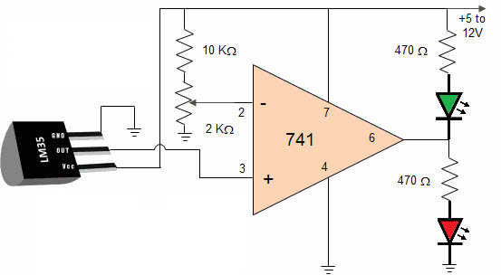

The amount produced by IC2 amplifies in an amount to the temperature by 10 mV per degree. This unstable voltage is supply to a comparator IC 741. OP Amplifier is the most generally used electronic devices today. The IC 741 op-amp is one sort of differential amplifier. We have used IC741 as a non-inverting amplifier which means pin-3 is the input and the output is not inverted. This LM35 temperature sensor circuit amplifies the difference between its input terminals. The advantages of temperature sensor include It has no effect on the medium, more accurate, It has an easily conditioned output and It responds instantly.

### 3.7.2 APPLICATIONS OF LM35 TEMPERATURE SENSOR

The applications of LM35 temperature sensor include the following

* Measuring temperature of a particular environment and HVAC applications
* Providing thermal shutdown [for a component](http://www.efxkits.us/what-are-the-electrical-components-used-in-electronic-projects/)/ circuit
* Checking Battery Temperature

**3.7.3 APPLICATION OF LM 35 TEMPERATURE SENSORS IN HUMAN BEING**

Body temperature measurement using LM35. It is required for the medium to be in contact with the package of the sensor to accurately measure the temperature of the medium. The time required by the sensor to provide stable and correct output varies with medium. It is required for the medium to be in contact with the package of the sensor to accurately measure the temperature of the medium. The time required by the sensor to provide stable and correct output varies with medium. Attached is the snapshot from DS. So it may be expected that (my own guess) one has to wait for more than a minute to have a stable output from LM35 for the human body temp measurement

**CHAPTER FOUR**

**4.0 SYSTEM IMPLEMENTATION AND DOCUMENTATION**

**4.1 IMPLEMENTATION OF THE SYSTEM**

This describes how the system works and how best computers together with other resources may be applied to perform data storage, management and retrieval for decision making. The requirements of this research work demand a web programming language.

**4.2 HARDWARE SUPPORT**

The hardware that is required in the successful completion of this project includes;

i. A system running on Laptop (Compaq nc6120).

ii. A random access memory (RAM) of 2GB.

iii. Enhanced Keyboard.

vi. A 250 GB hard disk.

v. Arduino Uno And Ethernet Shield

**4.3 SOFTWARE SUPPORT**

The software support for the design of the proposed system involves:

i. A windows 7 operating system.

ii. IDE ardunio Software.

iii. Xampp server.

iv. sublime text

v. My SQL database.

vi. An internet access as well as an anti-virus software which prevents the system from

being infected by virus.

**4.4 DOCUMENTATION OF THE SYSTEM**

In order for the proposed system to be used on any computer system it takes the following ways:

i. Boot the system.

ii. Install the Xampp server.

iii. Turn server on (Active).

iv. Copy the folder to www inside Xampp folder of the drive C: after Xampp server is

installed on the system.

v. Open any browser on the system (Microsoft internet Explorer, Mozilla Firefox,

Netscape Navigator, Opera, Flock, Safari etc.)

vi. Type http://localhost/temp/index.php on the address bar and press the return key

or enter key.

**4.4.2 PROCEDURE DESIGN**

This refers to the step by step method of using the proposed system.

1. The connection of Arduino Uno, LM 35 temperature sensor and Ethernet shield with breadboard.
2. Using IDE Arduino software to develop the coding for temperature sensor.
3. PHP and HTML is used to display the value of the temperature on a webpage
4. MySQL: which is xampp used to store the value of the temperature into the database.

**4.4.3 OPERATING THE SYSTEM**

The system developed requires the user to be trained by the programmer, this will enable the user to be familiar with the stages contained in the program and the function of each stage in the system is expected to be explained in details by the programmer. Before running the program, the application discussed above has to be installed on the personal computer (PC) and launched by the user.

* 1. **OUTPUT DESIGN AND INPUT DESIGN**

**4.5.1 ARDUINO UNO AND TEMPERATURE SENSOR CONNECTION**

This diagram shows the connection between the Arduino Uno and temperature Sensor With Breadboard.

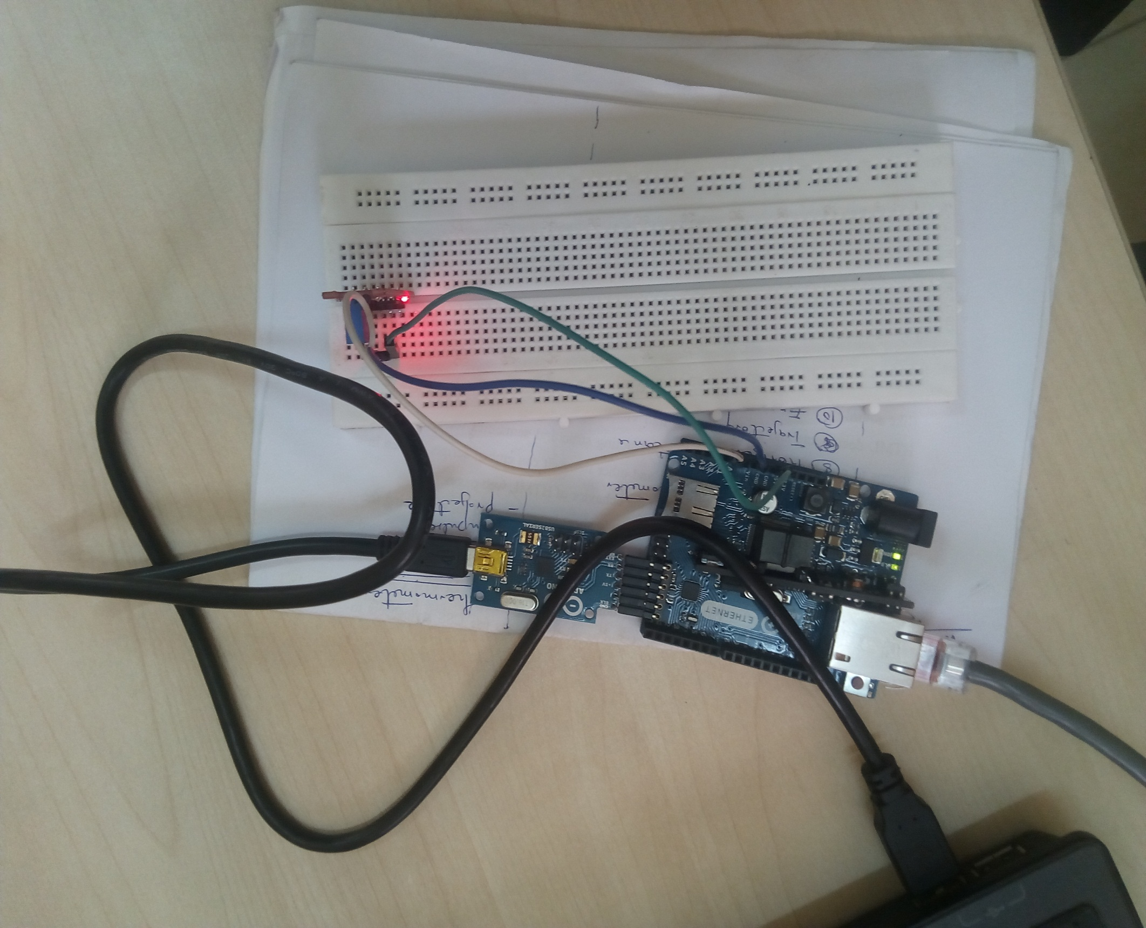

**4.5.2 THE OUTPUT OF ARDUINO UNO AND TEMPERATURE SENSOR**

This is the output of temperature sensor value generated by IDE Arduino Software . the temperature is displaying the value of Celsius.

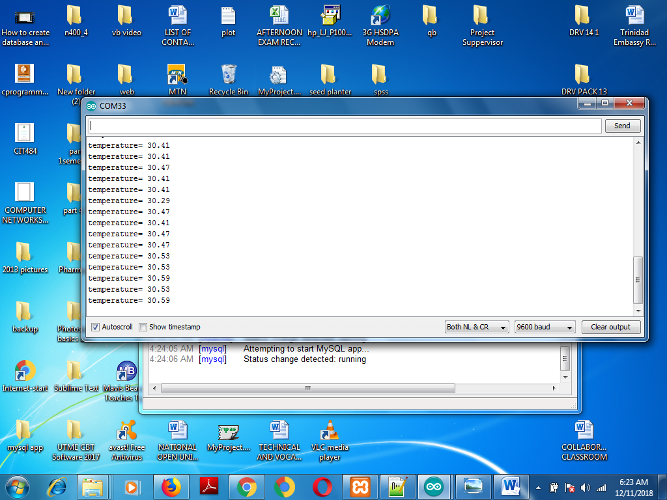

**4.5.3 THE TEMPERATURE SENSOR TABLE IN DATABASE (XAMPP)**

Xampp is the database management software that is used to store the value of the temperature sensor generated by the Ethernet shield.

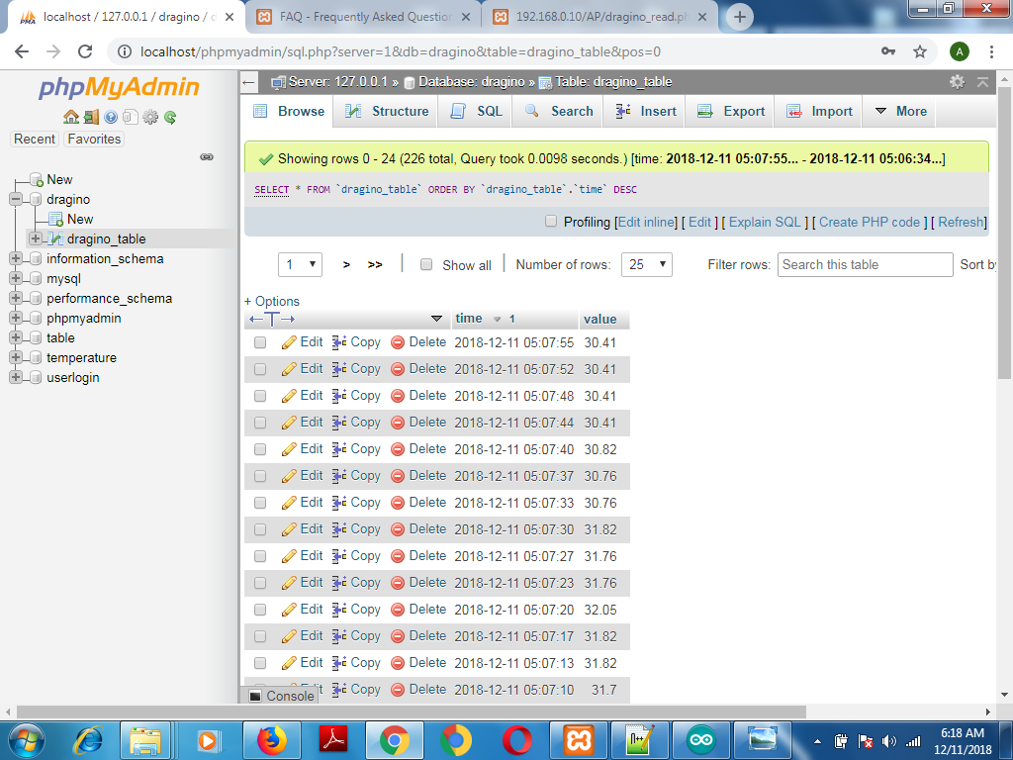

**4.5.4** **THE BAR CHART DISPLAY IN THE WEBPAGE**

The reading of the temperature sensor is display on the webpage as a bar chart.

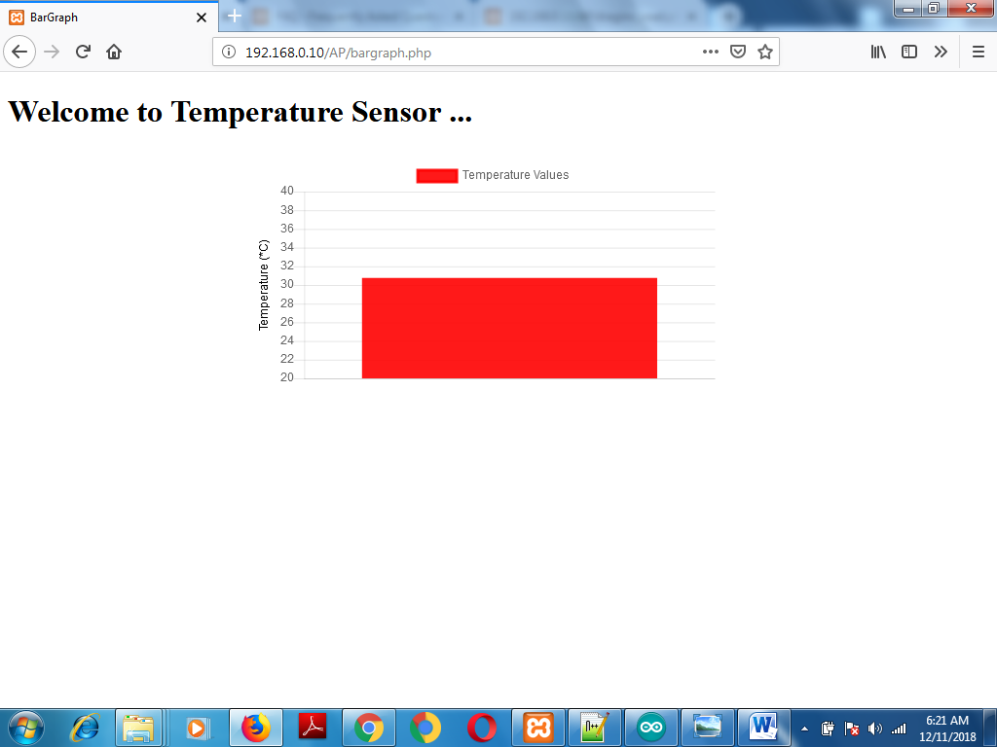

**CHAPTER FIVE**

**5.0 SUMMARY, CONCLUSION AND RECOMMENDATION**

**5.1 SUMMARY**

The quest to make life easier and processing faster has led to computerization of various processes. Computer technology has transformed so many sectors especially the hospital sector in no small measure. In an effort to foster technology driven hospital, a temperature monitoring system has been developed to manage all hospital operations such testing the temperatures of the patients.

**5.2 CONCLUSION**

In conclusion, from proper analysis and assessment of the designed system it can be safely concluded that the system is an efficient, usable and reliable. It is working properly and adequately meets the minimum expectations that were for it initially. The new system is expected to give benefits to the users and management in terms of efficiency in the usage of temperature monitoring system.

**5.3 RECOMMENDATION**

For further research work to be carried out. I hereby suggest the following.

1. The temperature sensor and biometric of the patent should be capture and stored in the database.
2. The system should give room for the operation of home nursing and proper checkup of patient temperature.
3. Hospital management should able to adopt the system in order to monitor the temperature of their client anywhere through the internet.
4. For the information of the patient to be well organized and store safely this system should be implemented.

**REFERENCE**

*Arduino. 2011a. Introduction*. Available: http://www.arduino.cc/en/Guide/Introduction. *Accessed: 13 April 2016*.

*Arduino. 2011b. Arduino Uno*. Available: http://arduino.cc/en/Main/arduinoBoardUno. *Accessed: 14 March 2016.*

*Arduino.2011c.ArduinoDue*.Available:http://www.arduino.cc/en/Main/ArduinoBoardDue. Ac-cessed: *19 March 2016****.***

*Arduino. 2011d. Arduino Shields*. Available: http://arduino.cc/en/Main/ArduinoShields. Accessed: *15 April 2016.*

*Banzi, M. 2011****.*** Arduino – Getting Started with Arduino. Maker Media, Inc. Banzi, M. 2012. Available: http://www.ted.com/talks/massimo_banzi_how_arduino_is_open_sourc-ing_imagination#.*Accessed: 14 March 2016*.

*Evans, B. 2011. Beginning Arduino Programming*. 2-3. New York: Apress. Fraden, J. 2010. Handbook of Modern Sensors: Physics, Designs, and Applications. Pringer Science & Business Media. [http://www.healthline.com/galecontent/ physical-examination. *(August 31, 2013)*.

*D. Mukherjee, K. Gupta, M. Pandey, and A. Agrawal,* “Microcontroller Based Cardiac

Counter System”, IJEAM, Vol. 02, Issue 01,April 2013 ISSN (Online):2320-6608.

*Eisman, Louis, Biology and Human Progress. Englewood Cliffs, NJ: Prentice Hall, 1972: 125. Simmers, Louise. Diversified Health Occupations. 2nd Edition, Canada: Delmar****,***

*1988:150-151.*

*R. Trivedi, G. Mathur, A. Mathur, “A Survey on Platinum Temperature Sensor”, IJSCE,* ISSN: 2231-2307, Volume-1, Issue-NCAI2011, June 2011.

*S. Mada, Sandhyarani S, “An Adaptive Embedded System for helping Patients”, IJCTT,*

Volume 2, Issue 2, 2011.

*Galen, a Greek scientist and physician, made the first attempt at measuring temperature in A.D. 170.There were several inventors working on thermoscopes around 1593,*

**APPENDIX A: CODE**

/ * AUTHOR: Itobi Abiodun

* DATE: 15 October 2018

* TITLE: Temperature Monitoring System

* BRIEF:

* byte mac[]: find it on the body of the Arduino Shield

* IPADDRESS: pick an IP address within the subnet mask of your computer IP Address

* char server[]: same as the IP Address of your computer

* host: same as the IP Address of your computer

*

code

* to void log_db and calls it.

*

* FUNCTION

* void log_db (int data)

* When the function is called the following happens;

* A connection is established (on port 80) between the server and the client.

* If the connection is unsuccessful Serial monitor print connection failed.

*

* An int type data must be passed to the function.

* The function wraps the data in a standard http request header and calls a (write_data).php to log

* the data into a mysql database.

*

* The connection is closed.

*

*

* /////////////////////////////////////////////////////////////////////////////

*/

#include <SPI.h>

#include <Ethernet.h>

byte mac[] = {

0x90, 0xA2, 0xDA, 0x0F, 0x8F, 0xC9 };

// Enter the IP address for Arduino, as mentioned we will use 192.168.0.16

// Be careful to use , insetead of . when you enter the address here

IPAddress ip(192, 168, 0, 16);

char server[] = "192.168.0.10"; // Important: Find theIP address of your computer and put it here (it is explained in previous article). If you have a web page, enter its address (ie. "www.yourwebpage.com")

// Initialize the Ethernet server library

EthernetClient client;

//initializing variables for LM35temperature sensor

int value=0;

float volts=0.0;

float temp=0.0;

//float tempF=0.0;

void setup() {

// Serial.begin starts the serial connection between computer and Arduino

Serial.begin(9600);

// start the Ethernet connection

Ethernet.begin(mac, ip);

}

void loop() {

value=analogRead(A0); //read from A0

volts=(value/1024.0)*5.0; //conversion to volts

temp= volts*12.0; //conversion to temp Celsius

// tempF=temp*9/5+32; //conversion to temp Fahrenheit

Serial.print("temperature= ");

Serial.println(temp);

log_db(temp);

delay(2000);

}

void log_db(float data){

// Connect to the server (your computer or web page)

if (client.connect(server, 80)) {

client.print("GET /AP/dragino_write.php?");

client.print("value=");

client.print(data);

// Serial.print(data);

// client.print(data);// And this is what we did in the testing section above. We are making a GET request just like we would from our browser but now with live data from the sensor

client.println(" HTTP/1.1"); // Part of the GET request

client.println("Host: 192.168.0.10"); // IMPORTANT: If you are using XAMPP you will have to find out the IP address of your computer and put it here (it is explained in previous article). If you have a web page, enter its address (ie.Host: "www.yourwebpage.com")

client.println("Connection: close"); // Part of the GET request telling the server that we are over transmitting the message

client.println(); // Empty line

client.println(); // Empty line

client.stop(); // Closing connection to server

}

else {

// If Arduino can't connect to the server (your computer or web page)

Serial.println("--> connection failed\n");

}

// Give the server some time to recieve the data and store it. I used 10 seconds here. Be advised when delaying. If u use a short delay, the server might not capture data because of Arduino transmitting new data too soon.

delay(1000);

}

**APPENDIX (B)**

PHP Code

*// Create connection*

*$conn = new mysqli($servername, $username, $password, $dbname);*

*// Check connection*

*if ($conn->connect_error) { //mysqli_connect_errno()*

*die("Connection failed: " . $conn->connect_error);*

*}*

*$sql = sprintf("SELECT time, value FROM dragino_table ORDER BY time DESC LIMIT 1 ");//select Time, Value field(s) respectively from SQL DB*

*//execute query*

*$result = $conn->query($sql);//$result=mysqli_query($con,$sql)*

*//execute query*

*//loop through the returned data*

*$data = array();*

*foreach ($result as $row) {*

*$data[] = $row;*

*}*

*//free memory associated with result*

*$result->close();*

*//close connection*

*$conn->close();*

*//now print the data*

*print json_encode($data);*

*?>*

**APPENDIX C**

*<html>*

*<head>*

*<title>BarGraph</title>*

*<meta name="viewport" content="width=device-width, initial-scale=1">*

*<meta charset="utf-8">*

*<style>*

*</style>*

*</head>*

*<body>*

*<div>*

*<h1>Welcome to Temperature Sensor ... </h1>*

*</div>*

*<div class="chart_container" style = "margin: auto; height:50%; width:50%; padding-top: 1vw; padding-bottom: 1vw">*

*<canvas id="mycanvas"></canvas>*

*</div>*

*<!-- javascript -->*

*<script type="text/javascript" src="jquery.min.js"></script>*

*<script type="text/javascript" src="Chart.min.js"></script>*

*<script type="text/javascript" src="dragino.js"></script>*

*</body>*

*</html>*